This is Violet. She is 3. She has got blonde
hair and blue eyes. Her hair is long. She has got a white dress.
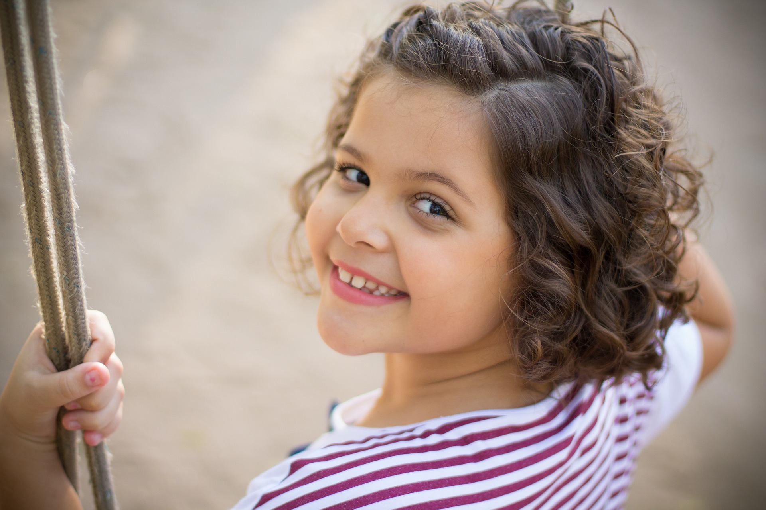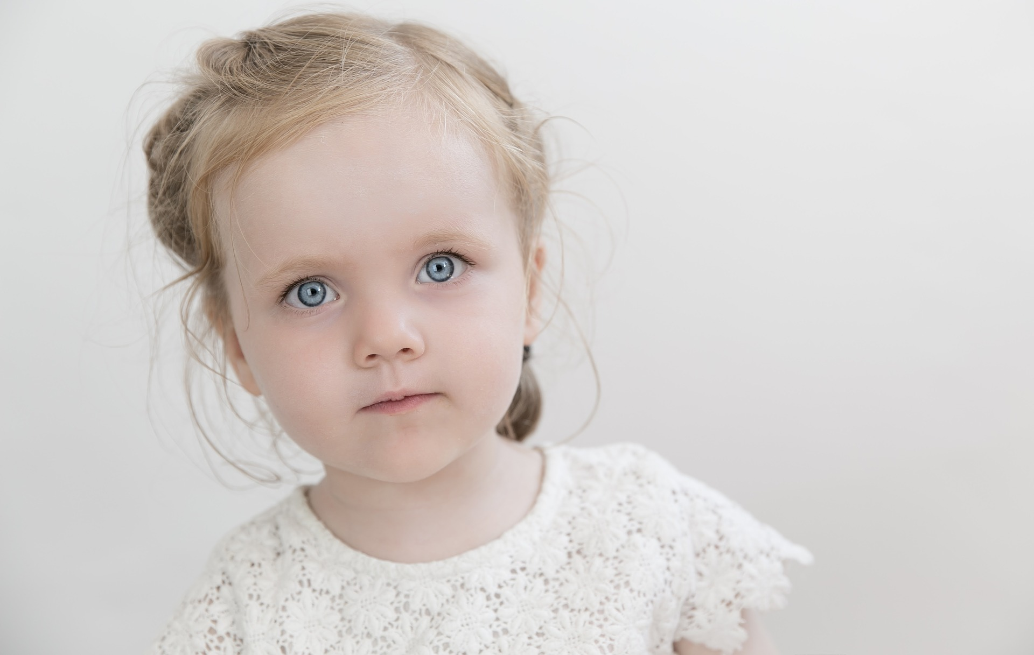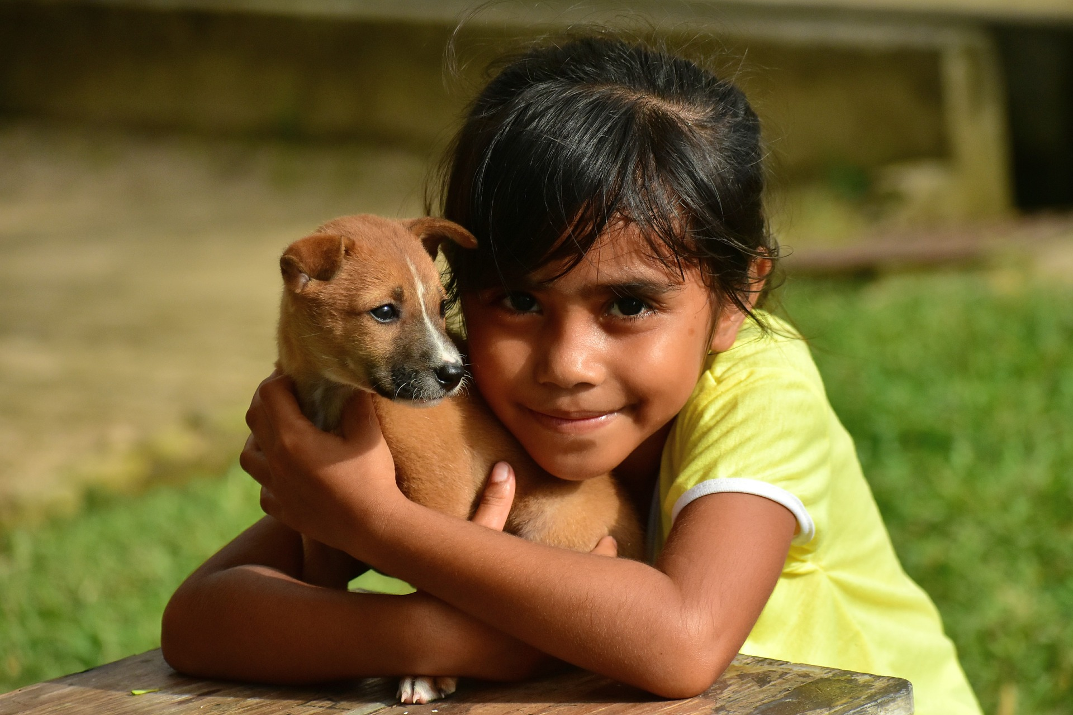
A B C

Who is Violet? _____

